Quickstart: bpm_orchestration4

Overview:
This quickstart illustrates how to incorporate human task management and ESB service orchestration into a single end-to-end business process. This document describes each step to execute the sample as well as attempts to provide the details necessary for you to extend this to your specific use cases and needs.

It is recommended that you first develop a comfort-level with the following quickstarts first as they are the building blocks for this particular example, in addition you'll be much more successful if you first execute these as individual tests before attempting this more complex example:
- business_rules_service – demonstrates how to use Drools as the business logic engine to enable Business Rules Services via the BusinessRulesProcessor Action.
- transform_XML2POJO2 – demonstrates the use of Smooks for performing XML to POJO conversions. In addition, this example shows how to use a Groovy script to determine the origin of a piece of XML and setup the right transformation profile.
- bpm_orchestration2 – demonstrates the use of jBPM to control the flow of execution across multiple ESB services. It does this through synchronous (request/response) calls into ESB services.
- bpm_orchestration3 – Demonstrates asynchronous invocations of ESB services and asynchronous signals of the process flow.

Validate your setup:
1. We recommend the use of the ESB Server download for new users as it is the easiest solution for getting started. It is a lightweight engine (Tomcat, JCA, JMS, ESB) that is specifically targeted at SOA & ESB use cases.
2. Verify that your ESB server is properly configured by using “run.bat” or “run.sh” in the ”bin” folder and using your browser to visit the following address: http://localhost:8080/

The result should look something like the following:
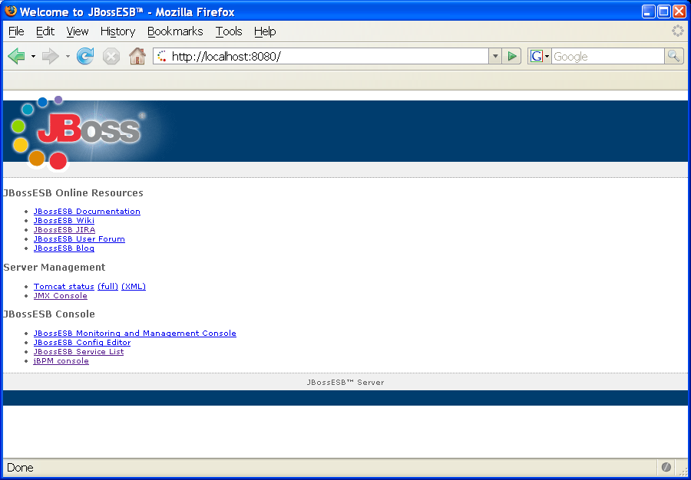
3. Click on the “jBPM console” link

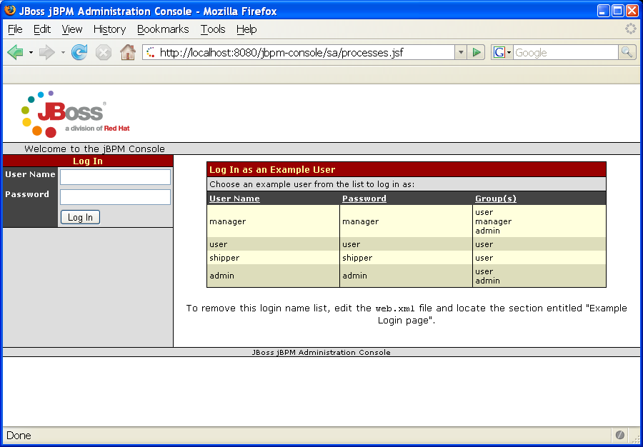
4. Login with “admin”, “admin”

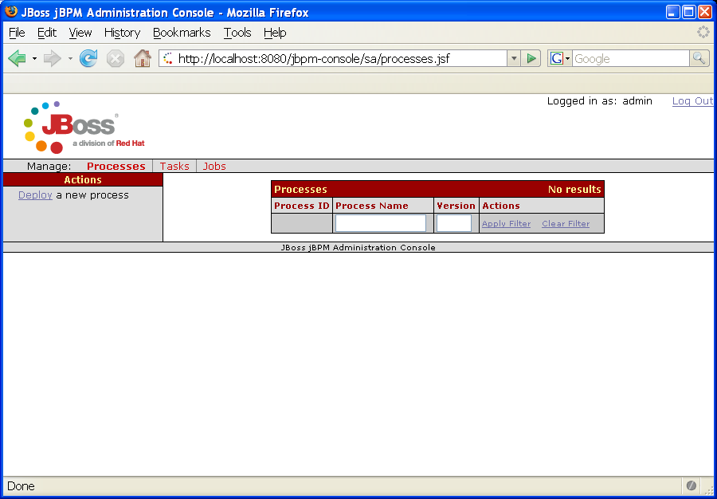

By default there are normally no processes preloaded, you could deploy a process definition using “ant deployProcess” from bpm_orchestration2 or bpm_orchestration3, however, we recommend that you experiment with JBoss Tools/JBoss Developer Studio and the jBPM Graphical Process Designer.

Download and configure your IDE to support the jBPM Graphical Process Designer. This step can be achieved by downloading Eclipse Europa (3.3) and adding JBoss Tools to it (http://labs.jboss.org/tools/) or by purchasing a preconfigured IDE (http://www.jboss.com/products/devstudio) or by downloading the jBPM JPDL Suite (http://labs.jboss.org/jbossjbpm/). This tutorial assumes you have acquired your tools and have a good understanding for how they work.

You can open the bpm_orchestration4 project in Eclipse by the following steps:
- File – New – Project
- Select Java Project
- Select Create project from existing source
- Browse... to the bpm_orchestration4 directory
- Set the Project name as “DEV_bpm_orchestration4”
- Select Finish

Right click on the processdefinition.xml in the processDefinition folder and select Open With – jBPM Graphical Process Designer.
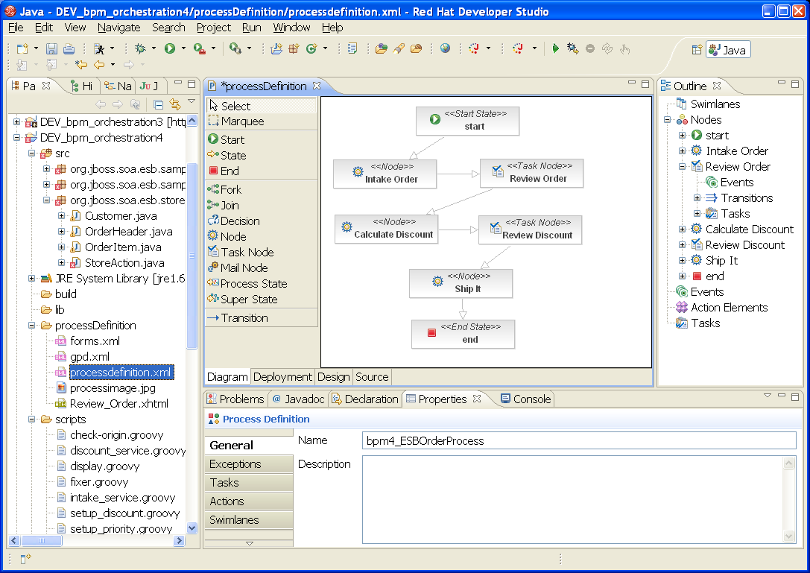
Deploy a Process Definition
1) Click on the Deployment Tab and click on the Test Connection... button. Make sure you get a “The server connection was successfully tested.” message.

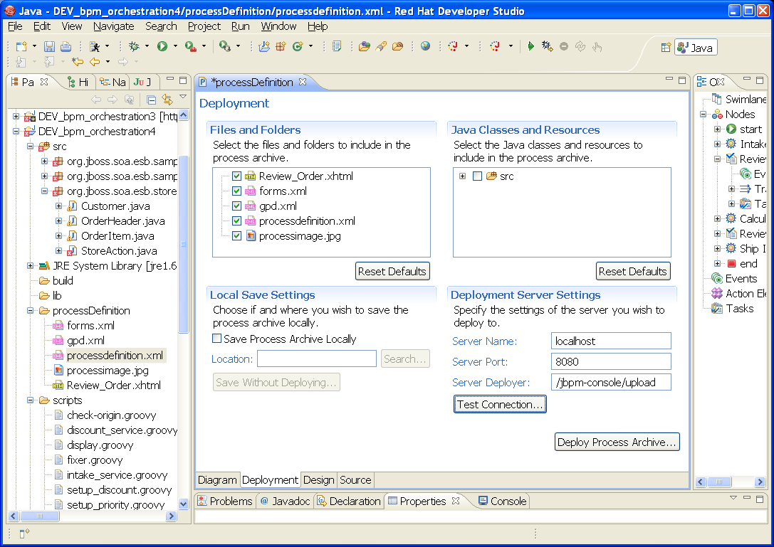
- Click on Deploy Process Archive..., you should receive a “The process archive deployed successfully.” message. Alternatively you can deploy the process definition using
ant deployProcess from the command line in the bpm_orchestration4 directory .

- Go back to the browser and refresh the page (or log in again as “admin”, “admin”) at http://localhost:8080/jbpm-console to see the new loaded process definition:
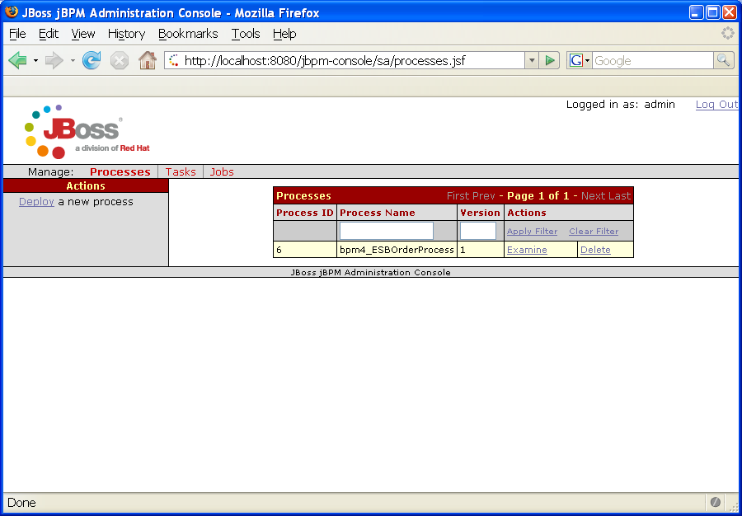
Note: the Process ID column will increment whenever you upload a new process definition. The version column will increment on a per process definition basis. The latest version will be used for the next inbound message/usage while “in-flight” messages/processes will continue to use the version they were started with.

Click on the “Examine” link beside bpm4_ESBOrderProcess and then on the Process Image link.

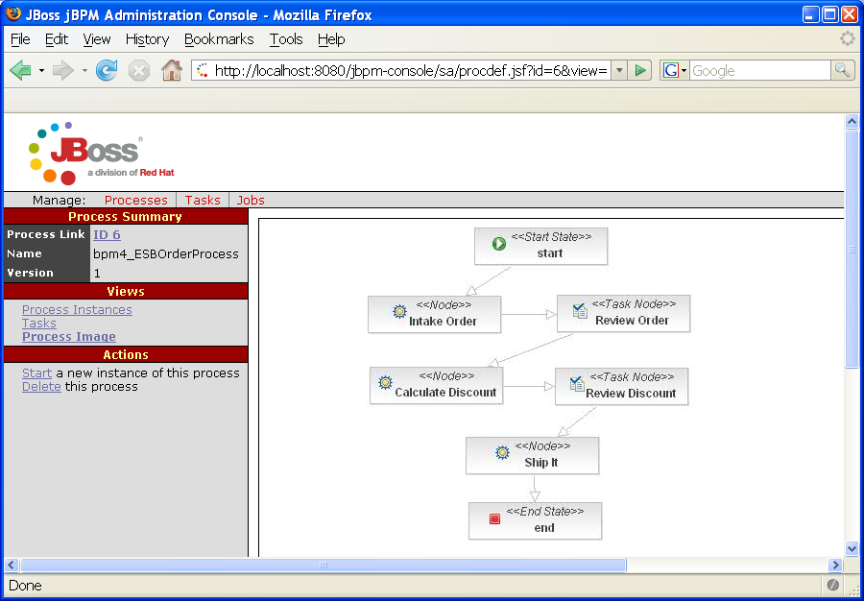

Deploy the ESB archive in bpm_orchestration4 by using the command “ant deploy”. You should notice that bpm_orchestration4.esb is created in an “exploded” directory under the server's deploy directory.

Now start a new process instance by using the command “ant startProcess”. The first node in the process definition is Intake Order which is mapped to the Intake Service.
On the Server console you should see something like the following:

11:06:16,203 INFO [STDOUT] == Begin Intake Service ==
11:06:16,203 INFO [STDOUT] DEFAULT: <Order orderId="2" orderDate="Wed Nov 15 13
:45:28 EST 2006" statusCode="0"
netAmount="59.97" totalAmount="64.92" tax="4.95">
<Customer userName="user1" firstName="Rex" lastName="Myers" state="SD"/>

<OrderLines>
<OrderLine position="1" quantity="1">
<Product productId="364" title="Superman Returns" price=
"29.98"/>
</OrderLine>
<OrderLine position="2" quantity="1">
<Product productId="299" title="Pulp Fiction" price="29.
99"/>
</OrderLine>
</OrderLines>
</Order>
11:06:16,203 INFO [STDOUT] == End Intake Service ==

and

11:06:16,484 INFO [SetupMessage] --------------------------------
11:06:16,484 INFO [SetupMessage] Customer: user1,Rex,Myers,SD
11:06:16,484 INFO [SetupMessage] Order: 2, Wed Nov 15 13:45:28 EST 2006, 0, 59.
97, 64.92, 4.95,
11:06:16,484 INFO [SetupMessage] businessKey: 2
11:06:16,484 INFO [SetupMessage] --------------------------------
11:06:16,484 INFO [SetupMessage] Moved the transformed Order Header and Custome
r
11:06:16,531 INFO [STDOUT] == BEGIN ==
11:06:16,531 INFO [STDOUT] orderHeader: 2, Wed Nov 15 13:45:28 EST 2006, 0, 59.
97, 64.92, 4.95,
11:06:16,531 INFO [STDOUT] customer: user1,Rex,Myers,SD
11:06:16,531 INFO [STDOUT] == END ==
11:06:16,671 INFO [STDOUT] Platinum Customer - High Priority
11:06:16,671 INFO [STDOUT] Customer Status: 60
11:06:16,671 INFO [STDOUT] Order Total: 64.92
11:06:16,687 INFO [STDOUT] *********** BEGIN ORDER PRIORITY FIXER ***********
11:06:16,703 INFO [STDOUT] Order: 2, Wed Nov 15 13:45:28 EST 2006, 0, 59.97, 64
.92, 4.95,
11:06:16,703 INFO [STDOUT] ************ END ORDER PRIORITY FIXER ************

What just happened: The “ant startProcess” command sends in a JMS message to the quickstart_bpm_orchestration4_start_gw queue which causes the BPM_orchestration4_Starter_Service:Starter_Service to execute (see the jboss_esb.xml). The Starter_Service uses the BpmProcessor action and the StartProcessInstanceCommand to begin the execution of a new process instance (a brand new inbound order starts a new process). The original XML message body is sent into the process instance as entireOrderAsXML using this section of the action's properties:

<property name="esbToBpmVars">
<mapping esb="BODY_CONTENT" bpm="entireOrderAsXML" />
</property>

The process is now waiting for human interaction, approval by the supervisor/manager therefore it is time to use the jBPM Admin Console to review & interact with the live process instance. Click on “Examine” by bpm4_ESBOrderProcess.

The process instance id is 1 and is assigned dynamically.

There is one known issue in this area of the jBPM Admin Console:
Start Date is displayed as GMT instead of local time

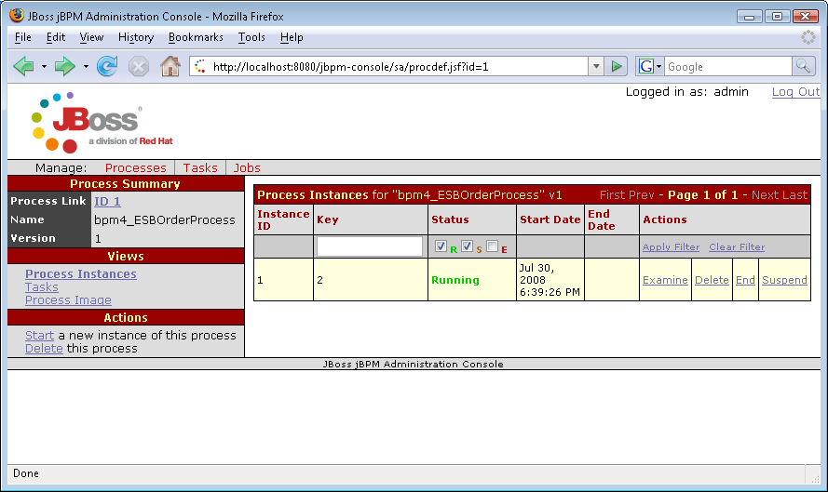
Now click on Examine for this newly created process instance.

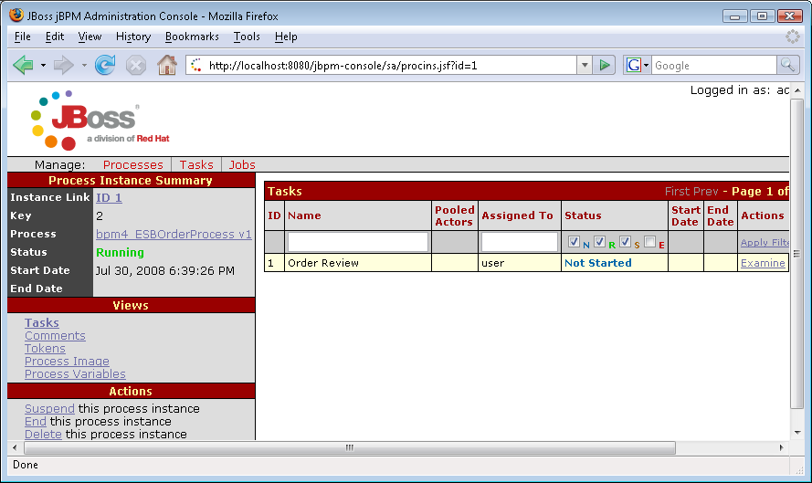
You should notice that there is a task called “Order Review” that was created. Now, in the left-hand navigation menu click on Process Variables.

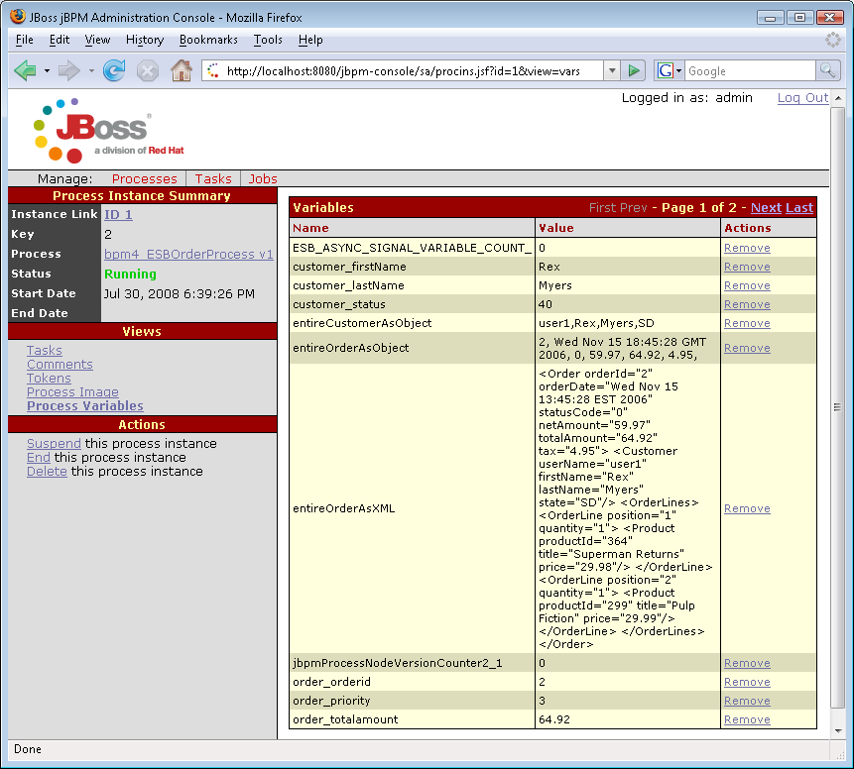
The Intake Service (review the jboss_esb.xml) primarily performs a transformation of the XML-based order into POJOs and runs the BusinessRulesProcessor action to calculate the “order_priority”.

In the jBPM Admin Console, click on Process Image.

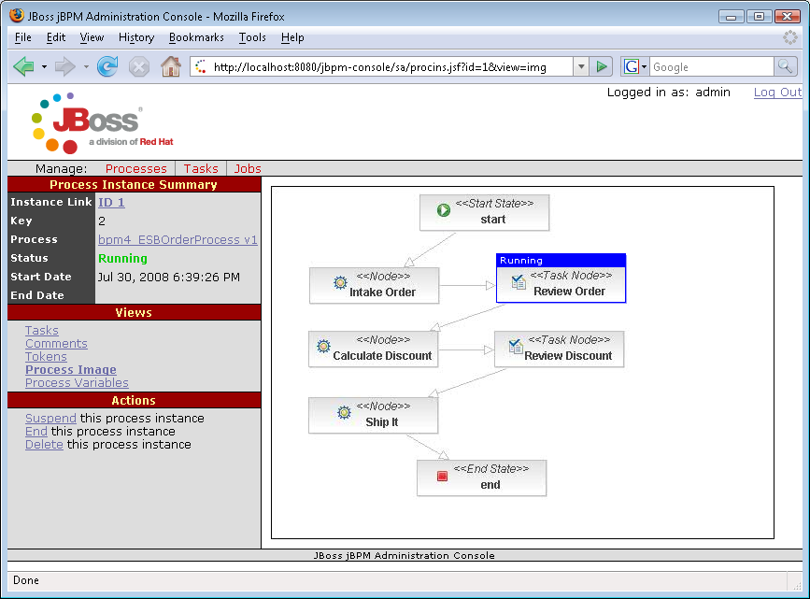
You should notice that the process is currently paused at the Review Order node.

Click on Tokens
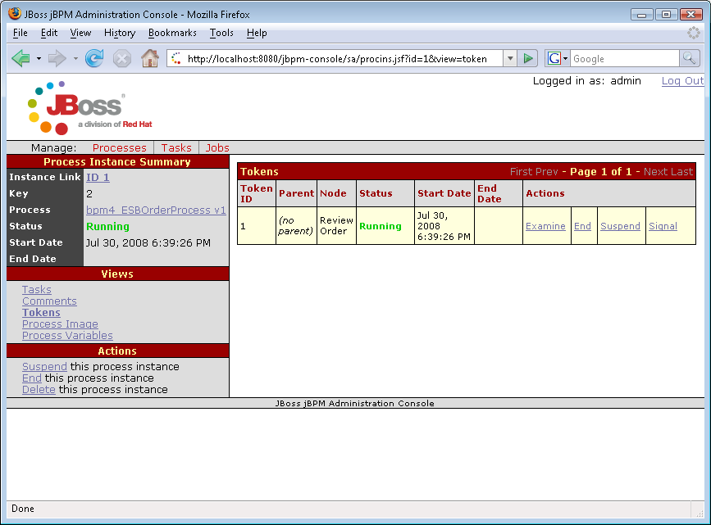
Again, you can see the process instance is waiting at the Review Order node. It should also be noted that this process instance has been persisted and will survive a server crash/shutdown. Feel free to restart the server, restart it and return to reviewing this process instance.

Click on Tasks
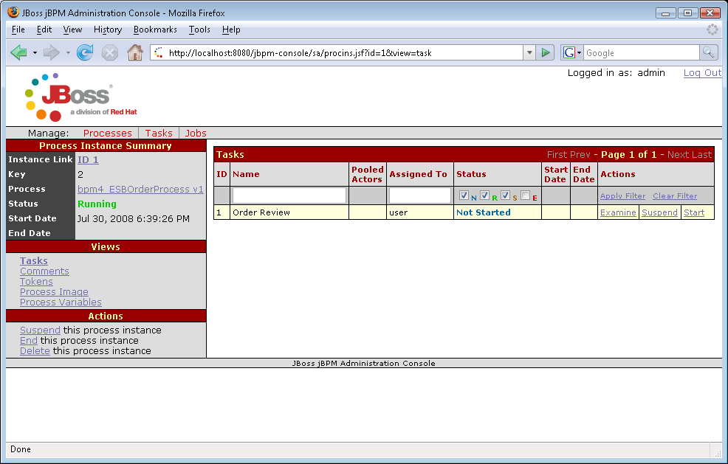
Then click on Examine beside the Order Review task. You will now see a form to interact with the live running process instance. Update the customer_status column from 40 to 65 and select Save. You should also make note of the fact that order_discount is blank at this time.

Note that you can also programmatically query the root token variables of any running process using the “GetProcessInstanceVariablesCommand” on the BpmProcessor action. This example illustrates this via the “BPM_orchestration4_Starter_Service:Get_Service_Vars_Sync” service, which can be seen in the jboss-esb.xml as follows:

<service category="BPM_orchestration4_Starter_Service" name="Get_Service_Vars_Sync"
description="BPM Orchestration Sample 4: Use this service to query the Service Variables" >
<listeners>
<jms-listener name="ESB-Listener" busidref="queryEsbChannel_sync"/>
</listeners>
<actions mep="RequestResponse">
<action name="GetVariables" class="org.jboss.soa.esb.services.jbpm.actions.BpmProcessor">
<property name="command" value="GetProcessInstanceVariablesCommand"/>
<property name="bpmToEsbVars">
<mapping bpm="entireCustomerAsObject" esb="body.customer" />
<mapping bpm="customer_firstName" esb="body.customer.firstName" />
<mapping bpm="customer_lastName" esb="body.customer.lastName" />
<mapping bpm="customer_status" esb="body.customer.status" />
<mapping bpm="entireOrderAsObject" esb="orderHeader" />
<mapping bpm="entireOrderAsXML" esb="BODY_CONTENT" />
</property>
</action>
</actions>
</service>

To see this service in action, run “ant queryProcessSync” from the quickstart folder.
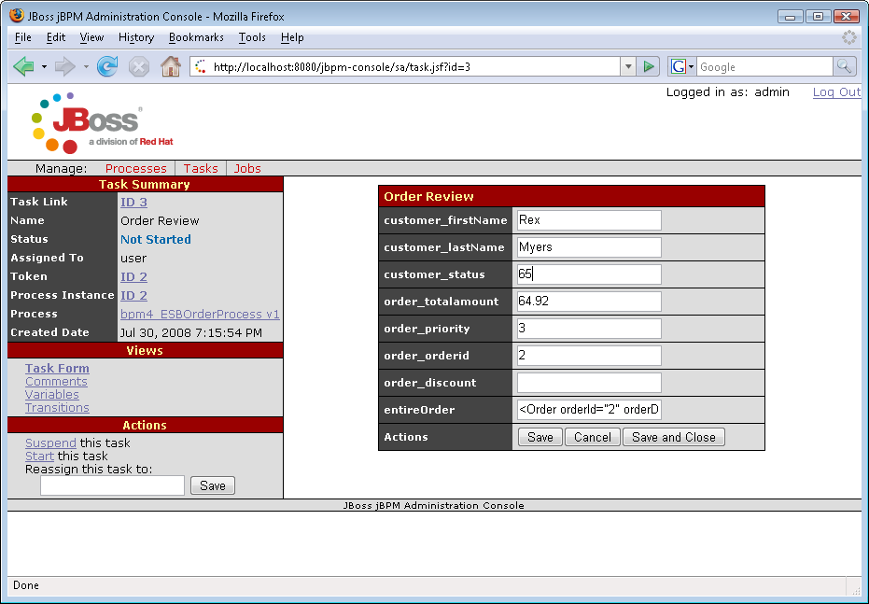

If possible make sure you have your Server console visible while performing the next step. When you select the Save and Close button this will cause the next node in the process to execute. That node is called Calculate Discount and it is mapped to the DiscountService defined in the jboss_esb.xml.

You should see like the following in the server console:
11:32:02,406 INFO [STDOUT] Begin Discount Service
11:32:02,406 INFO [STDOUT] default location: <Order netAmount="59.97" orderDate
="Wed Nov 15 13:45:28 EST 2006" orderId="2" statusCode="0" tax="4.95" totalAmoun
t="64.92">
<Customer firstName="Rex" lastName="Myers" state="SD" userName="user1"><
/Customer>
<OrderLines>
<OrderLine position="1" quantity="1">
<Product price="29.98" productId="364" title="Superman Returns"></Product>
</OrderLine>
<OrderLine position="2" quantity="1">
<Product price="29.99" productId="299" title="Pulp Fiction"></Product>
</OrderLine>
</OrderLines>
</Order>

Now return to the jBPM Admin Console and drill down on bpm4_ESBOrderProcess and the running process instance. The process is now waiting at Review Discount.
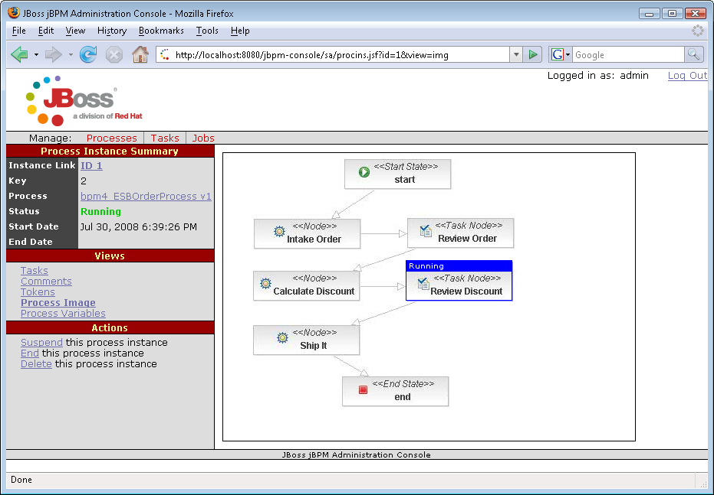
Click on Process Variables to see that “order_discount” is now 8.6 (as determined by the business rules).
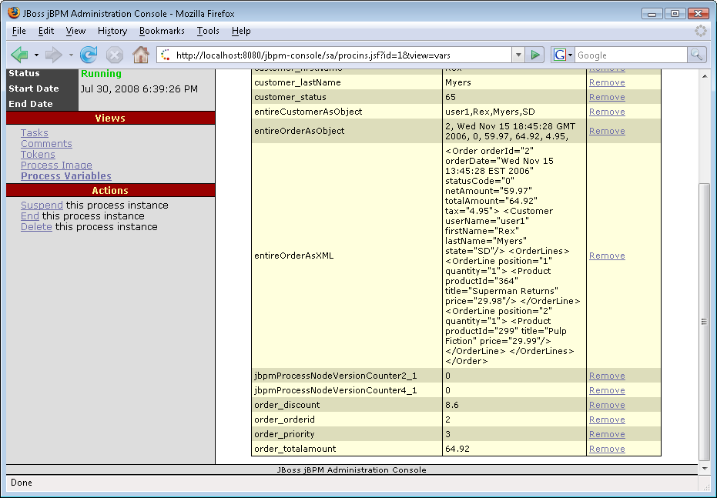

Click on Tasks and then “Examine” beside the Discount Review Task.
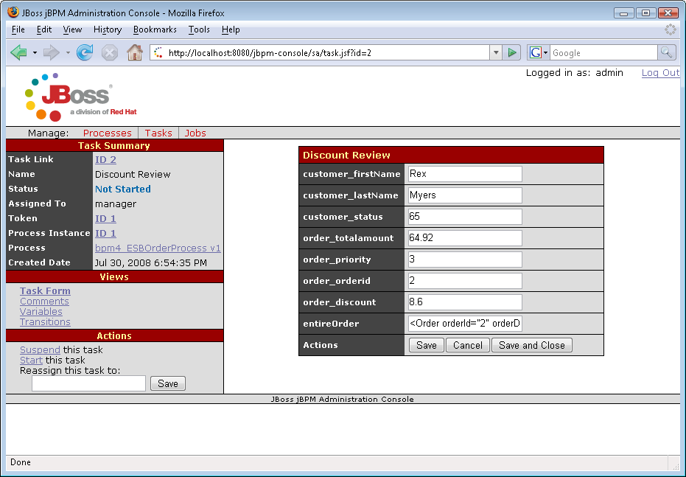

The order_discount is now populated in the form. Use the Save and Close button to execute the Shipping Service and end the overall process instance.

Make sure to review the processdefinition.xml via a text editor or the Source tab in the Graphical Process Designer. The mapping of a node to a ESB service is contained in the XML.

<node name="Calculate Discount">
<action name="esbAction" class= "org.jboss.soa.esb.services.jbpm.actionhandlers.EsbActionHandler">
<esbCategoryName>BPM_Orchestration4</esbCategoryName>
<esbServiceName>DiscountService</esbServiceName>
<bpmToEsbVars>
<mapping bpm="entireCustomerAsObject"
esb="body.customer" />
<mapping bpm="customer_firstName"
esb="body.customer.firstName" />
<mapping bpm="customer_lastName"
esb="body.customer.lastName" />
<mapping bpm="customer_status"
esb="body.customer.status" />
<mapping bpm="entireOrderAsObject"
esb="orderHeader" />
<mapping bpm="entireOrderAsXML"
esb="BODY_CONTENT" />
</bpmToEsbVars>
<esbToBpmVars>
<mapping bpm="entireOrderAsObject" esb="order" />
<mapping esb="body.order_orderDiscount"
bpm="order_discount" />
<mapping esb="body.customer.firstName"
bpm="customer_firstName" />
<mapping esb="body.customer.lastName"
bpm="customer_lastName" />
<mapping esb="body.customer.status"
bpm="customer_status" />
</esbToBpmVars>
</action>

<transition name="" to="Review Discount"></transition>
</node>

This is an example of Calculate Discount node.

The Ship It node is mapped to the ShippingService which uses the ContentBasedRouter to determine the appropriate place to route the message too.

The jboss-esb.xml has several instances of the following action:
<action name="monitor" class="org.jboss.soa.esb.samples.quickstarts.bpm_orchestration4.esb_actions.SimpleJMSNotifier">
<property name="ALERT_QUEUE_NAME" value="quickstart_bpm_orchestration4_monitor" />
<property name="PREPENDED_TEXT" value="Concierge:Highest Priority Customers/Orders" />
<property name="BODY_KEY" value="orderHeader" />
</action>

This is used to display interesting data along the flow of execution. You can run the monitor by using “ant startMonitor”.

